**Exercise 13: Online Bookstore – Unit Testing REST Controllers**

**Business Scenario:**

Write unit tests for your bookstore's REST controllers using JUnit and Mockito.

1. **JUnit Setup:**

* JUnit and Mockito was done set in the project by adding the dependencies in pom.xml file:

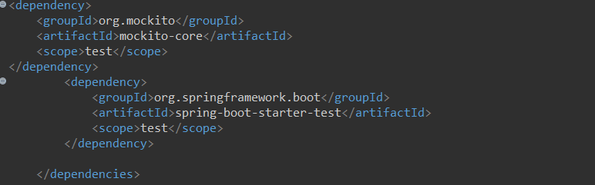

1. **MockMvc:**

* Used MockMvc to write unit tests for REST controllers:

Unit Testing: Given a value and check whether API is returning the same value, if the test matches it is successful else not successful.

**BookControllerTest.java:**

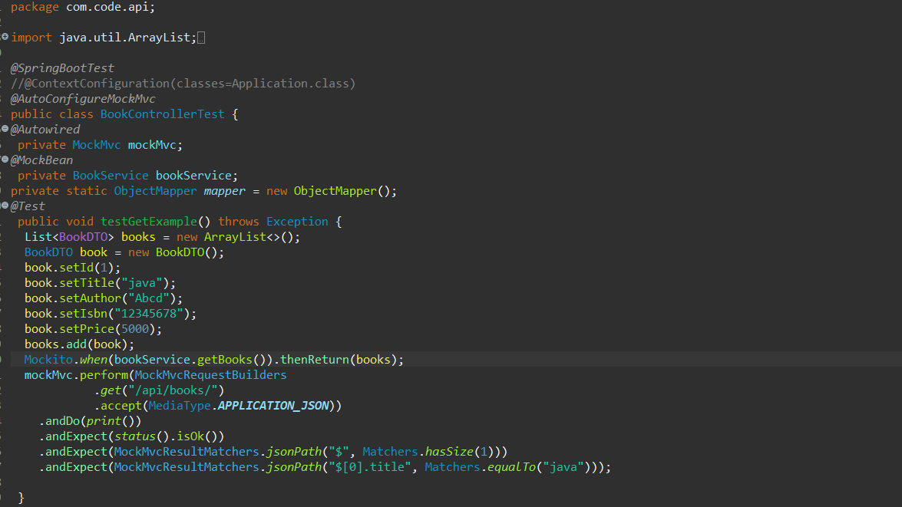

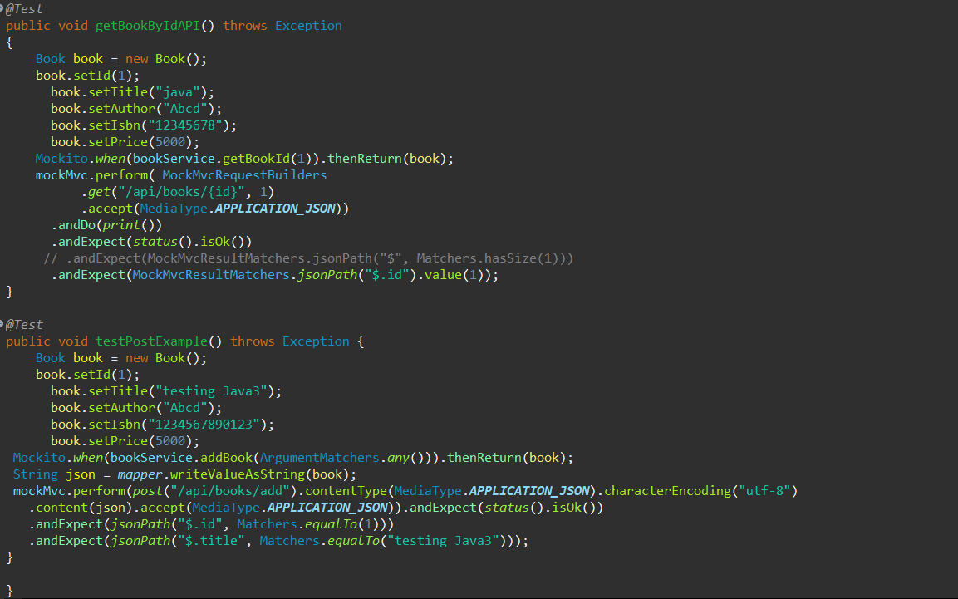

1. **Test Coverage:**

* Ensured comprehensive test coverage and followed best practices for testing.

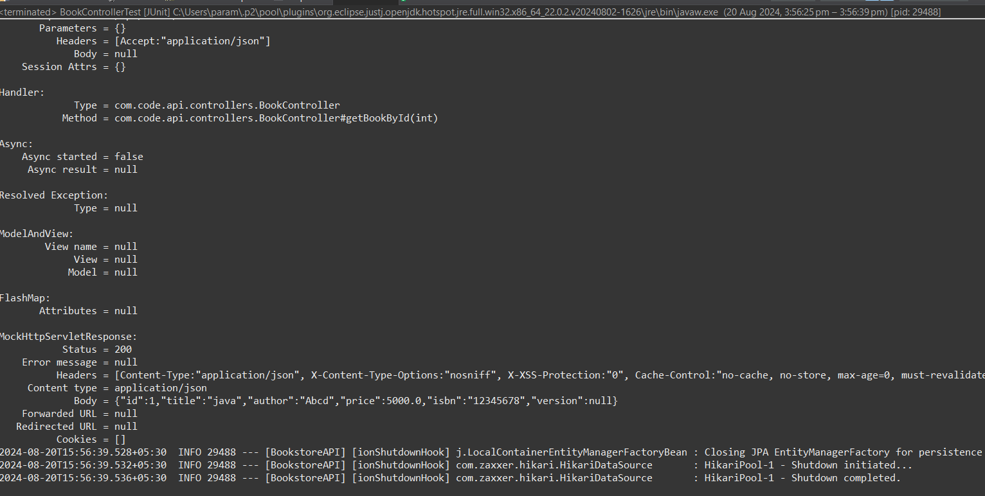

Junit test:

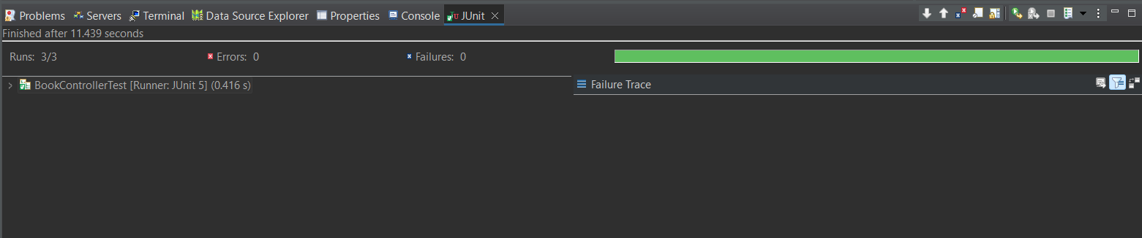

Green shows test successful

Changing the testing configurations:

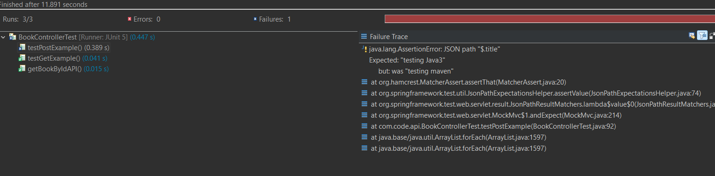

Red shows failure.